IDEA¹:
Ethical Decision-Making Guide

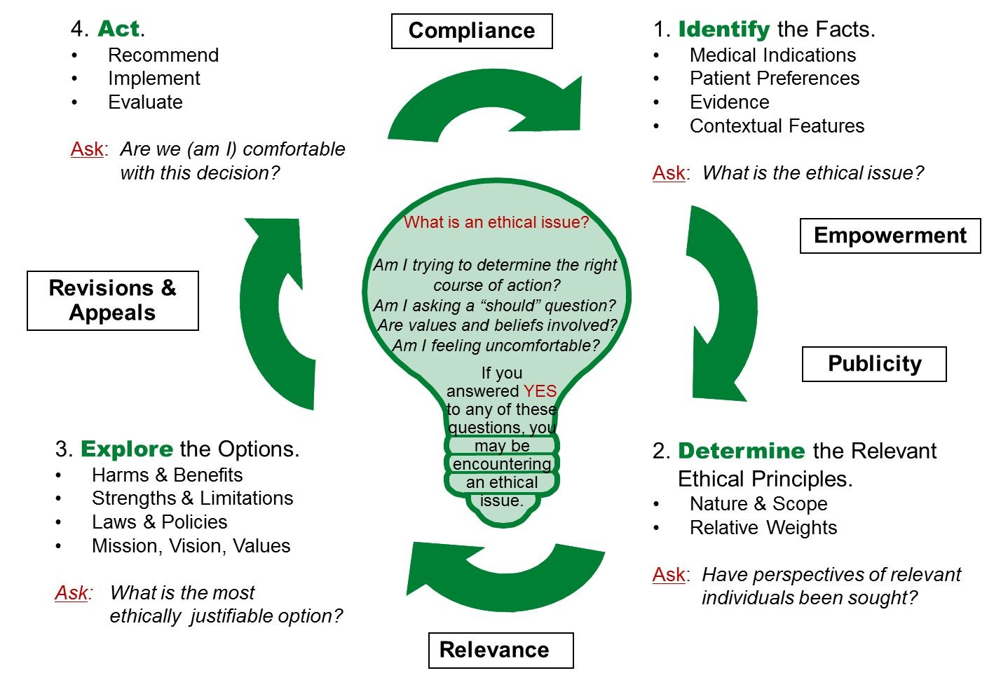
Figure 1:

¹ The IDEA: Ethical Decision-Making Framework was developed by the Regional Ethics Program based at Trillium Health Partners. It builds heavily upon the Toronto Central Community Care Access Centre Community Ethics Toolkit (2008), which was based on the work of Jonsen, Seigler, & Winslade (2002); the work of the Core Curriculum Working Group at the University of Toronto Joint Centre for Bioethics; and incorporates aspects of the accountability for reasonableness framework developed by Daniels and Sabin (2002) and adapted by Gibson, Martin, & Singer (2005).

The IDEA: Clinical and Organizational Ethical Decision-Making Framework is comprised of four steps and incorporates five conditions identified as important in the accountability for reasonableness framework developed by Daniels and Sabin (2002) and adapted by Gibson, Martin, and Singer (2005). The first letter of each step in this framework forms the acronym “IDEA.” In the centre of the framework there is a light-bulb (a further reference to the framework’s acronym, IDEA). The light-bulb contains a set of questions to assist healthcare providers/administrators in the identification of ethical issues to which the framework can be applied. The framework is depicted as circular, suggesting that decisions need to be revisited as new facts emerge.

The four steps are:
- Identify the facts.
- Determine the relevant ethical principles.
- Explore the options.
- Act.

The five conditions are:
- Empowerment:
There should be efforts to minimize power differences in the decision-making context and to optimize effective opportunities for participation (Gibson et al., 2005).
- Publicity:
The framework (process), decisions and their rationales should be transparent and accessible to the relevant public/stakeholders (Daniels & Sabin, 2002).
- Relevance:
Decisions should be made on the basis of reasons (i.e., evidence, principles, arguments) that “fair-minded” people can agree are relevant under the circumstances (Daniels & Sabin, 2002).
- Revisions and Appeals:
There should be opportunities to revisit and revise decisions in light of further evidence or arguments. There should be a mechanism for challenge and dispute resolution (Daniels & Sabin, 2002).
- Compliance (Enforcement):
There should be either voluntary or public regulation of the process to ensure that the other four conditions are met (Daniels & Sabin, 2002).

Reference the IDEA: Ethical Decision-Making Guide to complete this worksheet.

Completed By: Date:

Step 1: Identify the Facts.
What is the presenting issue(s)?
What are the relevant medical or other indicators?
What are the patient(s) preferences? (If applicable)
What is the evidence?
What are the contextual features?
What are your personal considerations? (e.g. issue of conscience, conflict of interest, emotions, bias)
What is the ethical issue?
IDEA: Ethical Decision-Making Guide Worksheets Name: PHN:
Step 2: Determine the relevant ethical principles.
Who are the stakeholders (relevant parties)? | What values/principles does each believe are relevant to the issue? | Which values/principles do stakeholders agree are most important in the current context? (Rate from 1 to ……)
 |  | 1)
 |  | 2)
 |  | 3)
 |  | 4)
 |  | 5)
 |  | 6)
 |  | 7)
 |  | 8)
 |  | 9)
 |  | 10)
 |  | 11)
 |  | 12)
 |  | 13)
Are there any other factors that need to be considered?
Have perspectives of relevant individuals been sought?

Step 3: Explore the Options.
Option 1: |  | Option 2: |  | Option 3:
Consistent with laws  Consistent with policies  Consistent with mission, vision, values & strategic directions |  | Consistent with laws  Consistent with policies  Consistent with mission, vision, values & strategic directions |  | Consistent with laws  Consistent with policies  Consistent with mission, vision, values & strategic directions
Benefits/Strengths: |  | Benefits/Strengths: |  | Benefits/Strengths:
Harms/Limitations: |  | Harms/Limitations: |  | Harms/Limitations:
Meets Decision Making Criteria (Create a check list) |  | Meets Decision Making Criteria (Create a check list) |  | Meets Decision Making Criteria (Create a check list)
 | Yes No |  | Yes No |  | Yes No
 | Yes No |  | Yes No |  | Yes No
 | Yes No |  | Yes No |  | Yes No
 | Yes No |  | Yes No |  | Yes No
 | Yes No |  | Yes No |  | Yes No
Additional Resources Needed: |  | Additional Resources Needed: |  | Additional Resources Needed:
What is the most ethically justifiable option?

IDEA: Ethical Decision-Making Guide Worksheets Name: PHN:
Step 4: Act.
Documentation/Communication of Decision (who, what, where, how):
Implementation Plan:
Evaluation Plan:
Did the process meet the five principles/conditions? | What is the evidence? | Reviewed by:
Empowerment:
Publicity:
Relevance:
Revisions and Appeals:
Compliance (Enforcement):
Are we (am I) comfortable with this decision?
The IDEA: Ethical Decision-Making Framework was developed by the Regional Ethics Program based at The Credit Valley Hospital and Trillium Health Centre. It builds heavily upon the Toronto Central Community Care Access Centre Community Ethics Toolkit (2008), which was based on the work of Jonsen, Seigler, & Winslade (2002); the work of the Core Curriculum Working Group at the University of Toronto Joint Centre for Bioethics; and incorporates aspects of the accountability for reasonableness framework developed by Daniels and Sabin (2002) and adapted by Gibson, Martin, & Singer (2005). Modified and used with permission from Dianne Godkin, RN, PhD (Senior Ethicist, The Credit Valley Hospital & Trillium Health Centre), March 22, 2012.

Ethical Decision-Making Checklist
Ethics is about making “right” or “good” choices and the reasons that we give for our choices and actions. Ethical decision-making frameworks help guide decision-making and actions about ethical issues that arise from the bedside to the boardroom. This checklist is based on Fair Process Principles (Accountability for Reasonableness) and considers procedural fairness during the decision-making process. Although this Checklist can be used separately, it is imbedded within the IDEA: Ethical Decision-Making Framework, which allows for an ethical analysis based on values and principles leading to evidence informed decisions.
No.: | Conditions: | Condition Met: | Condition Unmet:
1 | Empowerment: Have there been efforts to minimize power differences in the decision-making context and to optimize effective opportunities for participation?
 | - Have relevant stakeholders been included and provided with an opportunity to participate, reflect and engage?
 | - Have concerns about power imbalances (real or perceived) been addressed?
 | - Have concerns about cultural safety been addressed?
2 | Publicity: Are the process, decisions and their rationales transparent and accessible to the relevant public/stakeholders?
 | - Has the decision-making process been transparent and accessible to the stakeholders?
 | - Have concerns about fairness/ justice been addressed?
 | - Has a conflict of interest or a personal bias/issue of conscience been declared?
3 | Relevance: Have decisions been made on the basis of reasons (i.e., evidence, principles and arguments) that “fair-minded” people can agree are relevant under the circumstances?⁴
 | - Have the discussions been based on facts, principles, legislation, and/or evidence?
 | - Have reasonable efforts been made to gather contextually relevant facts?
 | - Has a cost/benefit analysis or a harm/benefit analysis been completed?
 | - Is the decision evidence-informed with a publically defensible rationale?
- Is the decision the most ethically justifiable when considering the organization`s mission, vision and values?
- Is there consensus on this decision and are we comfortable with it?
4 | Revisions & Appeals: Have there been opportunities to revisit and revise decisions in light of further evidence or arguments and is there a mechanism to challenge and contest the decision?⁴
- Is there a process to re-evaluate the decision?
- Is there a process to resolve a contested decision?
5 | Compliance (Enforcement): Has there been a review process to ensure that the other four conditions have been met, as part of evaluation and continuous improvement?^{3,}
- Have the other four conditions been met throughout the decision-making process?
- If not, are we able to articulate good reasons to our stakeholders?
Appendix A: What is an Ethical Issue?

Ethics is about:
- Deciding what we should do (what decisions are morally right or acceptable);
- Explaining why we should do it (justifying our decision in moral terms); and
- Describing how we should do it (the way we respond).
- Determining when we should do it (act at one point in time may provide a benefit, same act another time may be a burden);
- Determining if we can do it (does one have the appropriate resources)

Ethical issues are often framed as “should” questions. For example:
- How should the organization make decisions about how much funding to provide to each of its programs?
- If there is a shortage of critical care beds, how should decisions about who to admit (and who not to admit) be made?
- Should life-sustaining treatment be continued for a patient for whom the treatment is burdensome with minimal benefit?
- Should a colleague’s alcohol abuse be reported?
- Should a patient be informed of a “near miss” in his or her care?

Ethical issues may involve one or more of the following:
- Ethical Uncertainty: When it is unclear what ethical principles are at play or whether or not the situation represents an ethical problem.
- Ethical Dilemma: When there are competing courses of action both of which may be ethically defensible (e.g., conflicting values) and there is a difference of opinion as to how to proceed
- Ethical (Moral) Distress: When you find yourself in a situation of discomfort, if you have failed to live up to your own ethical expectations, or if you are unable to carry out what you believe is the right course of action due to organizational or other constraints
- Ethical Violation: When an action that appears to be unethical is being proposed or carried out (e.g., a patient is being given a treatment without providing a valid consent.

Daniels, N., & Sabin, J. (2002). Setting limits fairly: Can we learn to share scarce resources? Oxford: Oxford University Press.

